1

#include<iostream>

using namespace std;

int main ()

{

const int value=10;

cout << value;

}

2

#include <iostream>

int main () {

int integerNum = 10;

std::cout << "Integer number: " << integerNum << std::endl;

float floatNum = 3.14;

std::cout << "Float number: " << floatNum << std::endl;

char charValue = 'A';

std::cout << "Character: " << charValue << std::endl;

return 0;

}

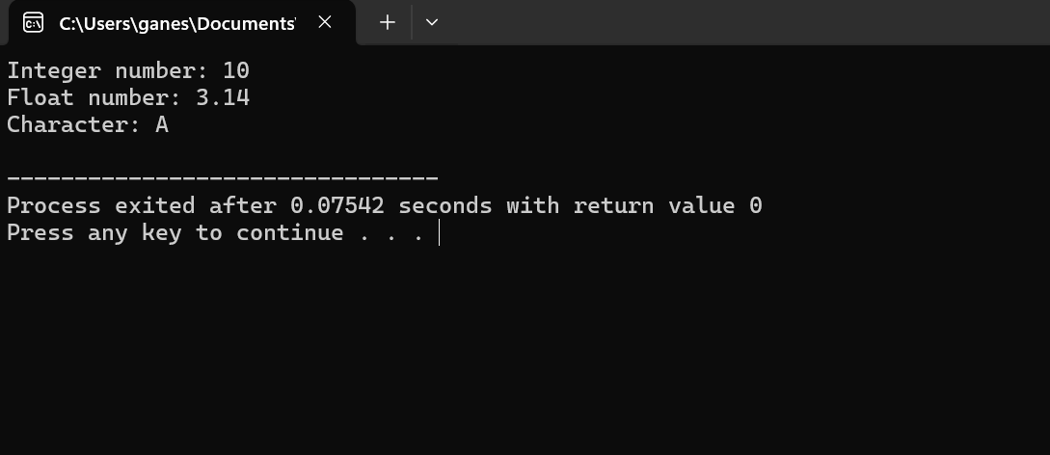

3

#include <iostream>

int main () {

int integerVar = 10;

float floatVar;

floatVar = integerVar;

std::cout << "Integer variable: " << integerVar << std::endl;

std::cout << "Float variable: " << floatVar ;

return 0;

}

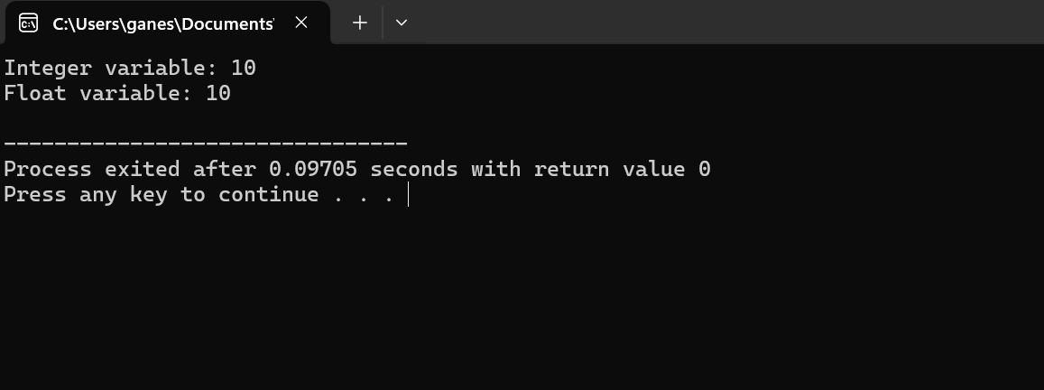

4

#include <iostream>

int main() {

int integerValue = 10;

float floatValue;

floatValue = integerValue;

std::cout << "Integer value: " << integerValue << std::endl;

std::cout << "Float value after implicit conversion: " << floatValue << std::endl;

return 0;

}

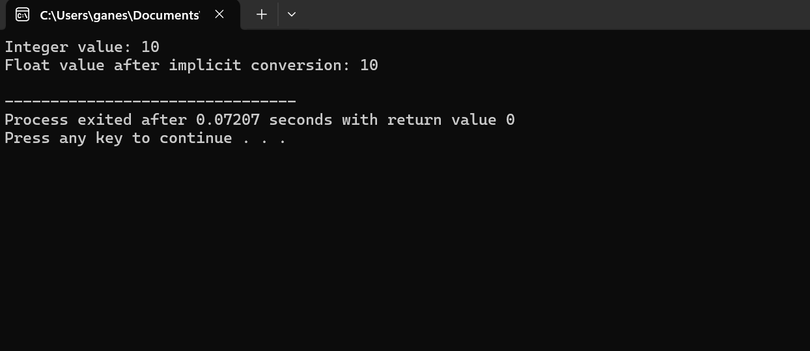

5.

#include<iostream>

using namespace std;

int main()

{

int a=2,b=4;

cout << "addition two integer variables"<<endl;

cout <<a+b;

}

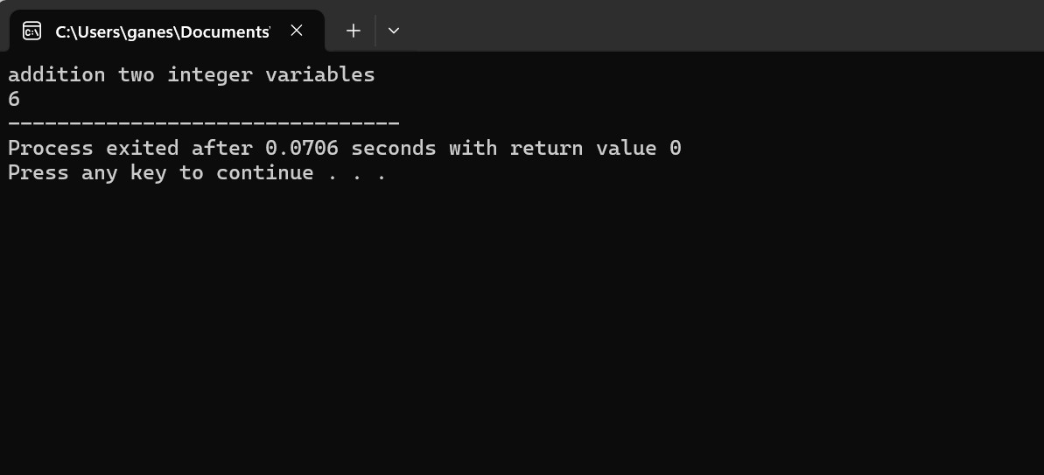

6

#include<iostream>

using namespace std;

int main()

{

int a=5;

if (a%2==0)

{

cout <<"even number";

}

else

{

cout <<"odd number";

}

}

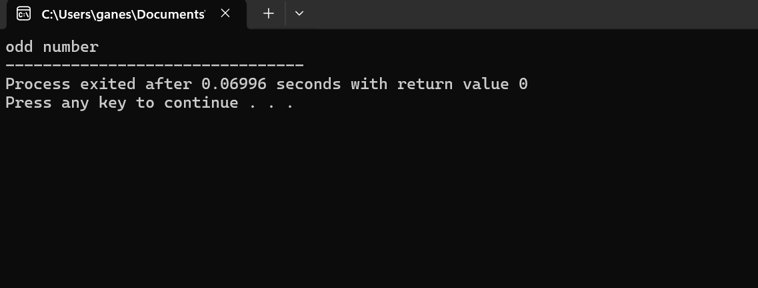

7

#include<iostream>

using namespace std;

int main()

{

int a[5]={1,2,3,4,5};

cout << "the array elements="<<endl;

for(int i=0;i<5;i++)

{

cout << a[i]<<"\n";

}

}

8

#include<iostream>

using namespace std;

int main()

{

int n;

cout <<"enter your choice=";

cin >>n;

switch(n)

{

case 1:

cout<<"sunday";

break;

case 2:

cout <<"monday";

break;

case 3:

cout <<"Tuesday";

break;

case 4:

cout <<"wednesday";

break;

case 5:

cout <<"thursday";

break;

case 6:

cout <<"Friday";

break;

case 7:

cout <<"saturday";

break;

}

}

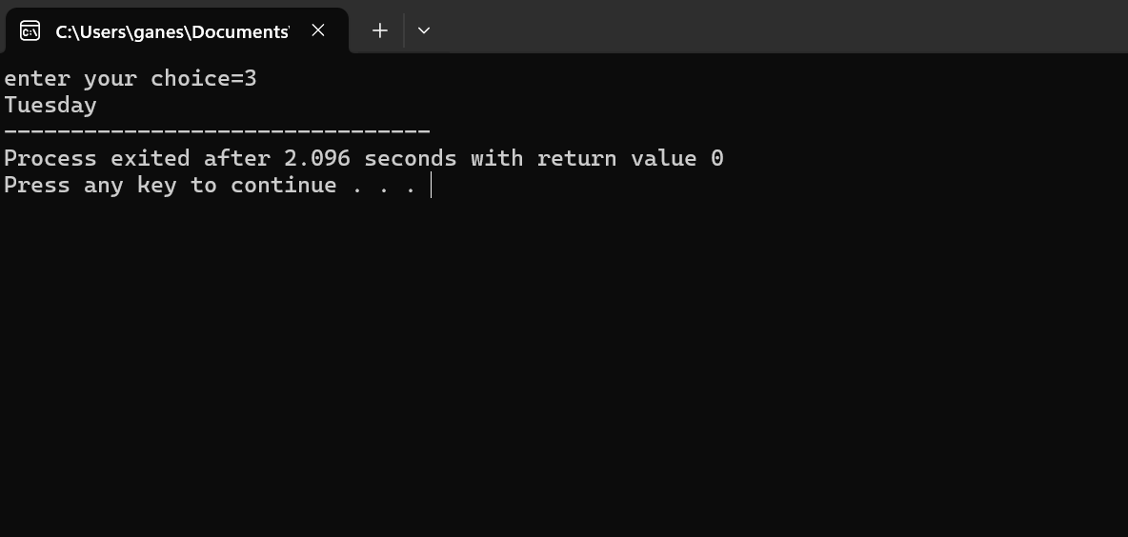

9

#include<iostream>

using namespace std;

int main()

{

int l,b;

cout <<"enter the length=";

cin >>l;

cout <<"enter the width=";

cin >>b;

int area=l\*b;

cout << "area of rectangle="<<area;

}

10

#include<iostream>

using namespace std;

int main()

{

int a,b,c;

cout <<"enter the three numbers=";

cin >>a >>b>>c;

if ((a>b) && (a>c))

{

cout <<a<<"is greater number"<<endl;

}

else if((b>a)&&(b>c))

{

cout <<b<<"is greater number"<<endl;

}

else

{

cout <<c <<"is greater number"<<endl;

}

}

